# **Description of the Data**

For this study we have used data by the: [Greek Fire Department](https://www.fireservice.gr/el_GR/synola-dedomenon), from the years 2014 – 2023. We have processed the preliminary raw data from years 2014 – 2023, to obtain usable data that will lead to a more efficient model. The raw data set, image 1.

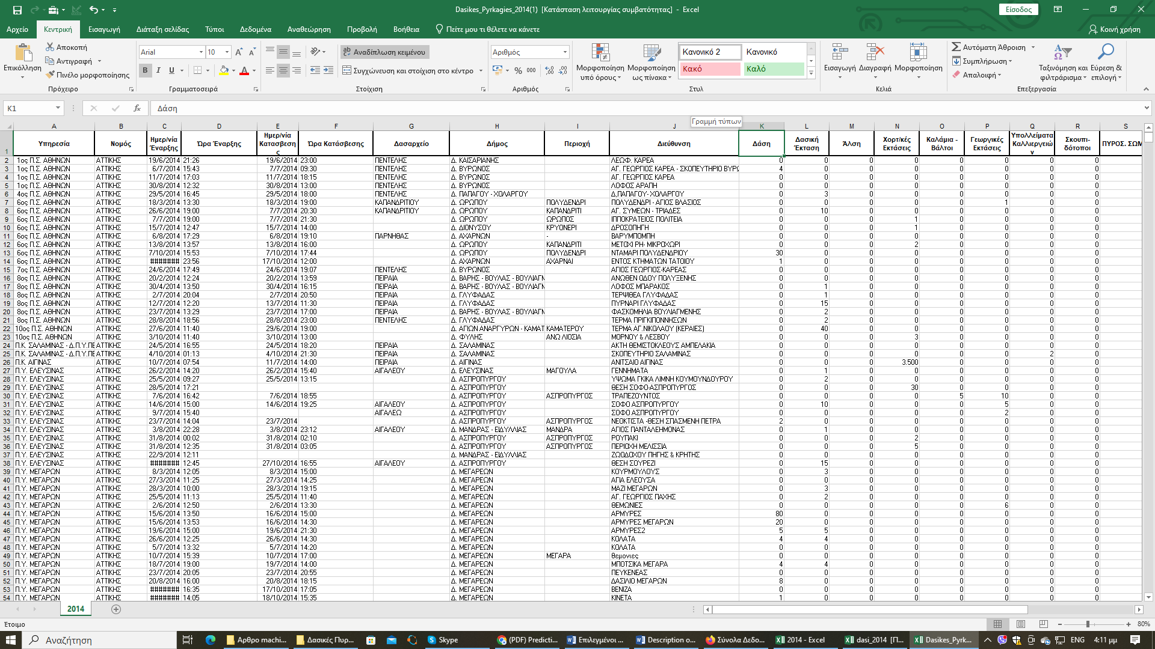Image 1. Data set by the Greek Fire Department.

The first step involved: data cleaning. In the second step, we merged the columns, containing the fire start & time, as well as the columns containing the fire extinguishment & time, in order to perform a subtraction and calculate the fire duration.

Then we identified three classes based on the fire duration (class 1, 3, 4). The data categorized was complemented with the classification, based on the Fire Department, the Region, and the Season. The data during processing, image 2.

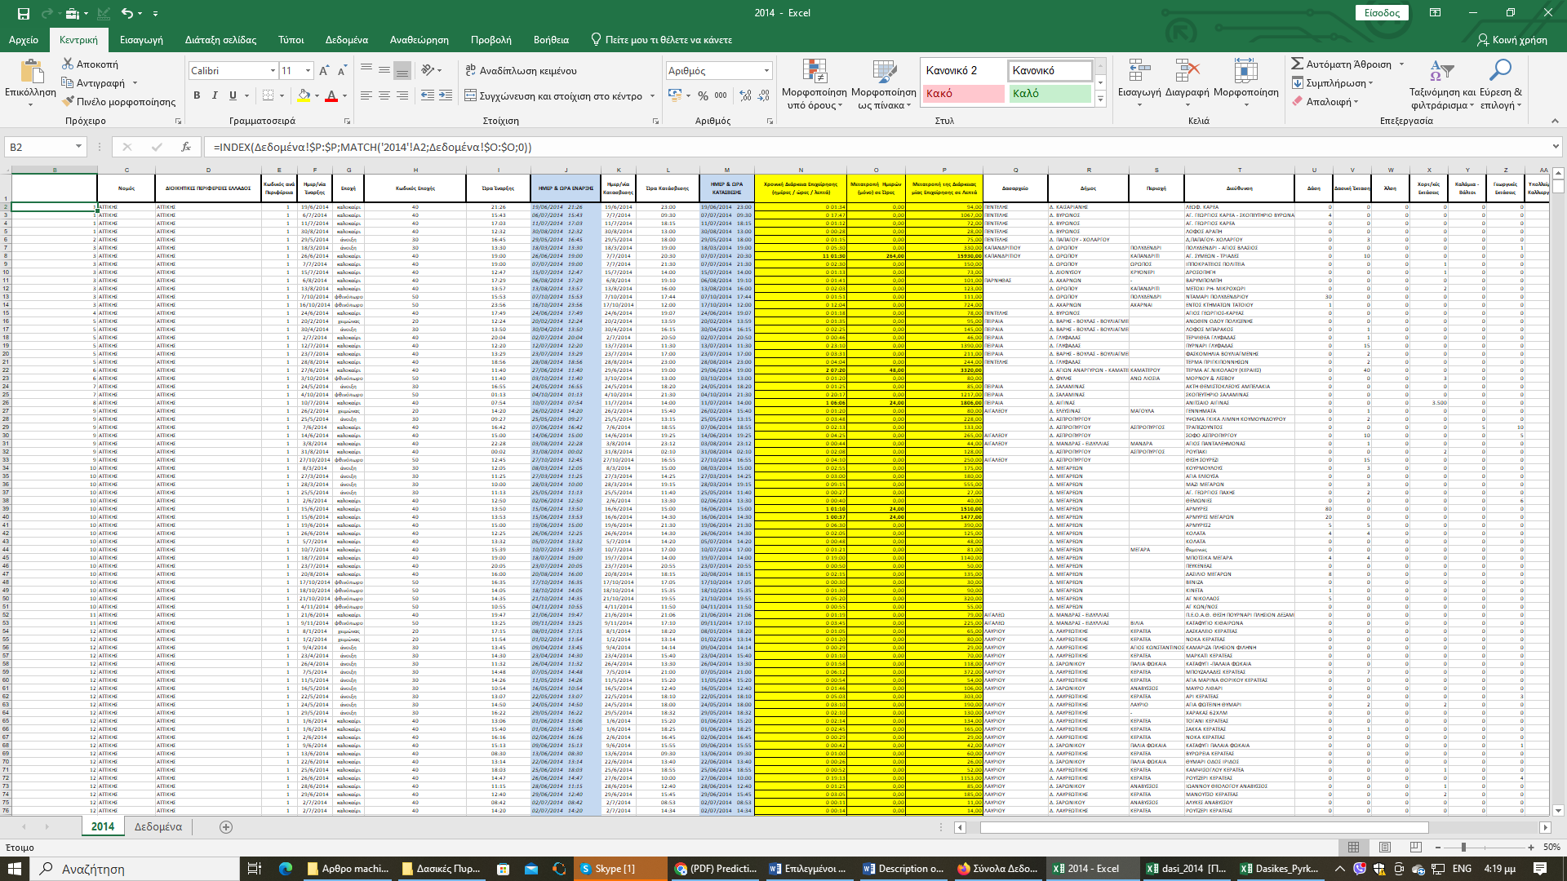Image 2. The processing data.

Our final dataset includes, 28 columns into an excel sheet∙ specifically: fire department, province, season, fuel (forest, forest area, grove, grasslands, reeds/swamps, agricultural lands, cover crop, garbage dumps) burnt area acres, manpower (Firefighters, volunteer, army, etc.), vehicles (firefighting, tanks, etc.), aerial means (helicopters, different aircrafts) duration, class and log. Final data, image 3.

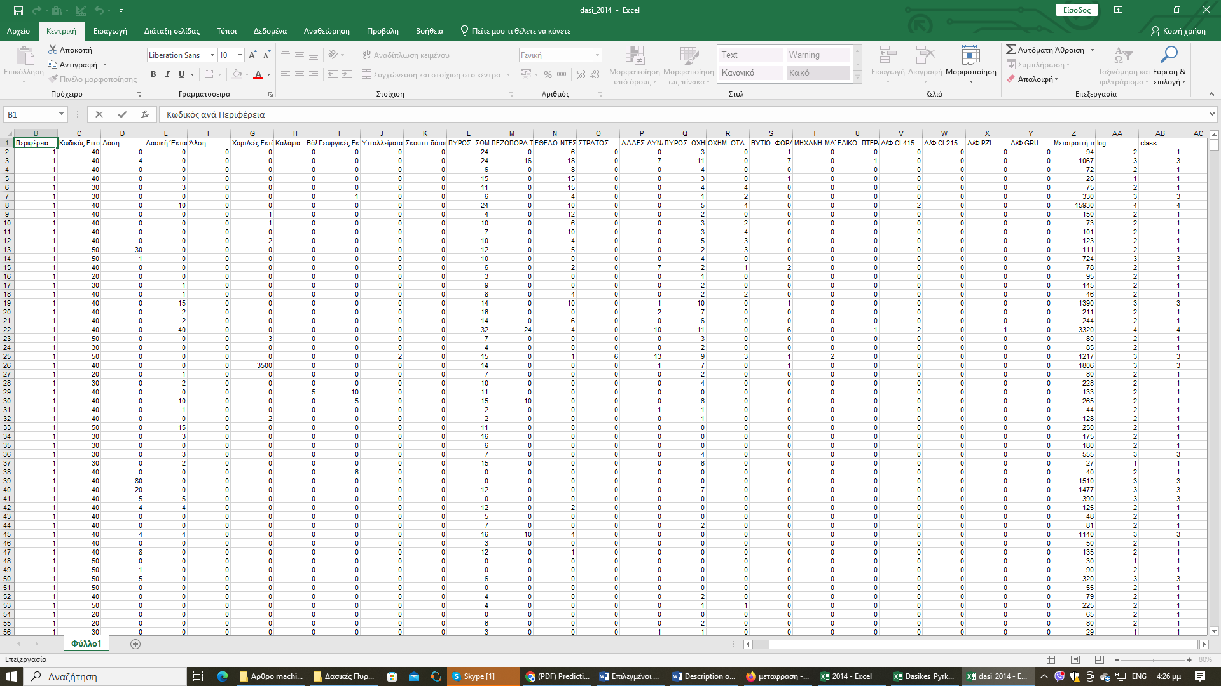Image 3. Final data.

We converted all the Excel files since 2014, into an ARFF file, and using (nom) the class for fire duration, we evaluated the performance of all algorithms, in WEKA.

After our evaluation, we choose, the algorithms: Bayes Net, Naïve Bayes, Logistic Regression, Multilayer Perceptron, J48, and Random Forest. In the table above, we can see the results, for the Incorrectly Classified Instances.

Table of Incorrectly Classified Instances.

|  |  |  |  |  |  |  |
| --- | --- | --- | --- | --- | --- | --- |
|  | **Bayes Net** | **Naïve Bayes** | **Logistic** | **MLP** | **J48** | **Random Forest** |
| **2014** | 11,44% | 12,89% | 9,81% | 11,37% | 10,04% | 9,42% |
| **2015** | 11,08% | 11,26% | 9,53% | 10,65% | 9,51% | 8,95% |
| **2016** | 25,71% | 13,00% | 3,41% | 3,90% | 3,65% | 3,00% |
| **2017** | 11,04% | 11,51% | 9,48% | 10,08% | 10,30% | 9,29% |
| **2018** | 11,20% | 10,46% | 9,09% | 9,48% | 9,27% | 8,58% |
| **2019** | 9,61% | 9,25% | 8,29% | 8,53% | 9,08% | 8,01% |
| **2020** | 18,00% | 6,72% | 5,54% | 5,97% | 6,09% | 5,50% |
| **2021** | 12,35% | 14,15% | 12,04% | 13,59% | 13,59% | 11,92% |
| **2022** | 10,25% | 9,62% | 9,01% | 9,47% | 9,04% | 8,93% |
| **2023** | 9,74% | 9,19% | 8,26% | 8,77% | 8,39% | 7,66% |
|  |  |  |  |  |  |  |
| **AVERAGE** | **13,04%** | **10,81%** | **8,45%** | **9,18%** | **8,90%** | **8,13%** |